LABMANUAL
CSA1517
CLOUD COMPUTING AND BIG DATA ANALYTICS FOR HADOOP APPLICATIONS
P.DILLI BABU
192472284
EXPNO 5: CREATE A SIMPLE CLOUD SOFTWARE
APPLICATIONFORLIBRARYBOOKRESERVATION
SYSTEMFORSIMATSLIBRARYUSINGANYCLOUD SERVICE PROVIDER TO DEMONSTRATE SAAS DATE:
AIM: To Create a simple cloud software application for Library book reservation system for SIMATS library using any Cloud Service Provider to demonstrate SaaS
PROCEDURE: step1: Go to zoho.com. step 2: Log into the zoho.com. step 3: Select one application step.
step4: Enter application name as library book reservation system. step 5: Created new application as library book reservation system. step 6: Select one form step 7: The software has been created.
OUTPUT:
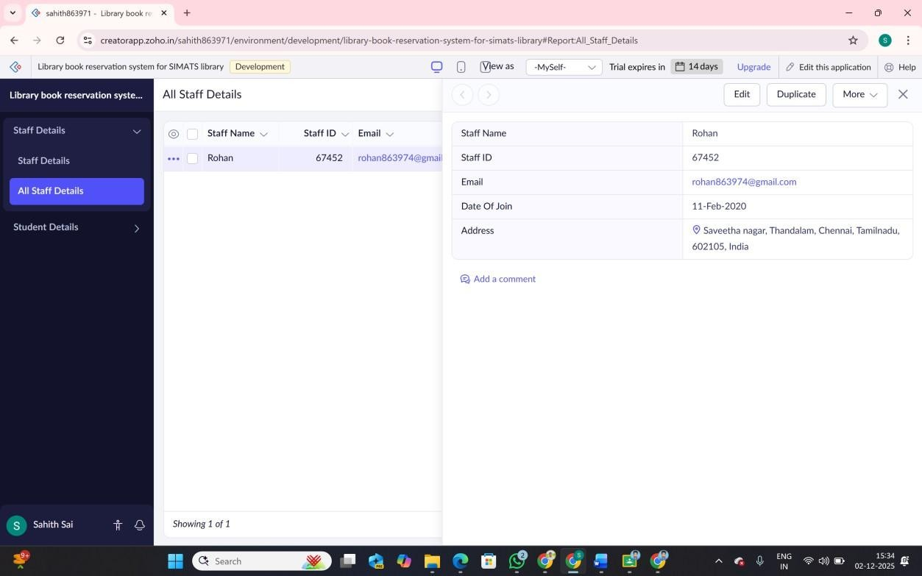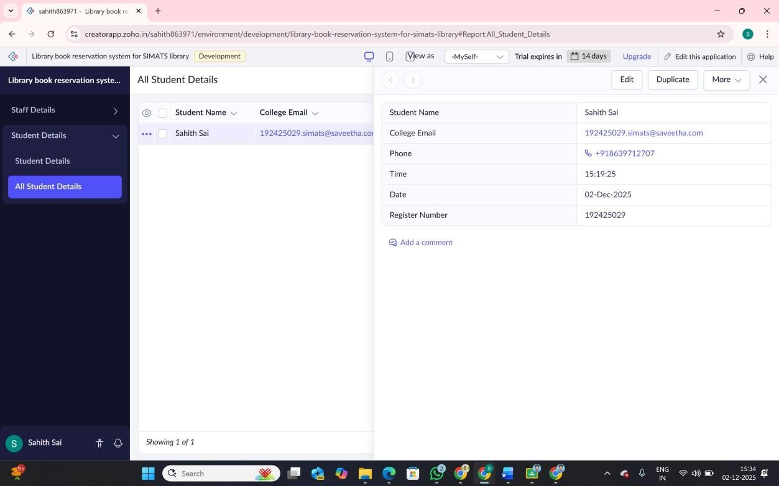
RESULT: For Using Cloud Service Provider Library book reservation system for SIMATS library is implemented successfully.

